Standard | Items:
K.CC.03  Write numbers from 0 to 20. Represent a number of objects with a written numeral 0-20 (with 0 representing a count of no objects). | 3.0  - “Write your numbers starting at 0. Use your best handwriting.”  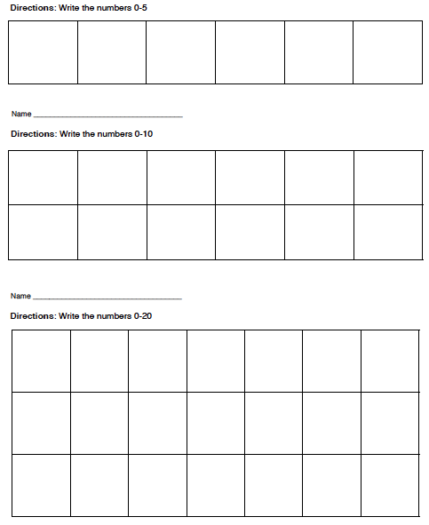  - “Count the stars and write the number that matches each quantity.”  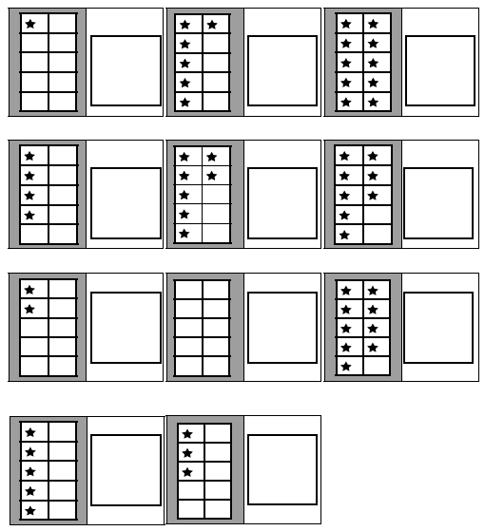  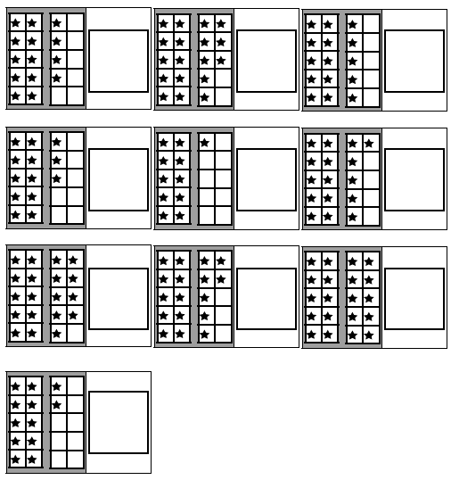
2.0
- “Write your numbers starting at 0. Use your best handwriting.”
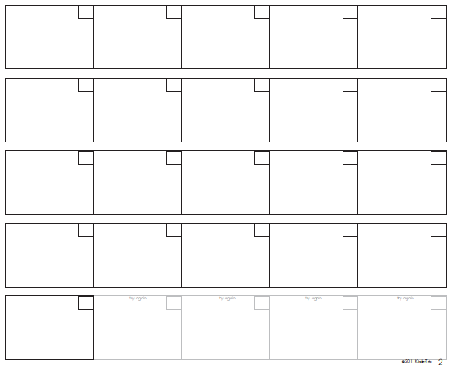

- “How many beach balls are there? Write the number in the box.”
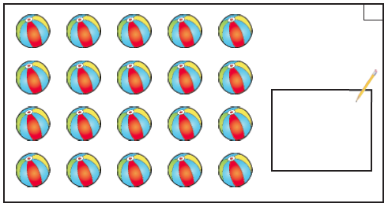
- “How many shells are there? Write the number in the box.”
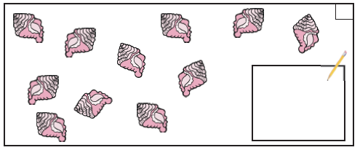
K.OA.01  Represent addition and subtraction with objects, fingers, mental images, drawings, sounds (e.g., claps), acting out situations, verbal explanations, expressions, or equations. | 3.0  Provide a container of bears, drawing paper and crayons for students to use if they choose.  - If there are 3 bears at the park and 2 bears at school, how many bears are there in all?  - If 8 bears are swimming and 2 go home, how many are left?  - There are some bears. Three more bears join in to make six (move in the three bears). How many bears were there to start if now there are 6?  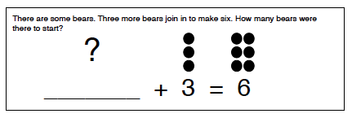
 | 2.0
K.MD.02  Directly compare two objects with a measurable attribute in common, to see which object has “more of”/“less of” the attribute, and describe the difference. For example, directly compare the heights of two children and describe one child as taller/shorter. | 3.0  Note: Show students several pencils (straws or sticks) of varying size.  - Line up three pencils in order of size. (Give student a fourth pencil.) Where will this pencil go?  - (Select a pencil in the middle.) Please describe this pencil in relationship to the other pencils.
2.0
Note: Show students 2 objects of different weight and length.
Which object is heaviest?
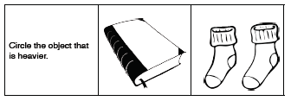
Which object is longest?
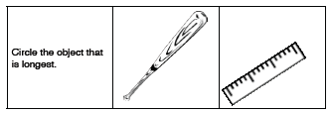
Tell me about the weight of these two things. (balls)
Tell me about the size of these two things. (people)
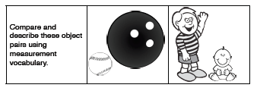
K.G.01  Describe objects in the environment using names of shapes, and describe the relative positions of these objects using terms such as above, below, beside, in front of, behind, and next to. | 3.0  - Look at the frisbee and the boy. Tell me where the frisbee is. Is it above or below the boy?  - Look at the boy and the bushes. Tell me where the boy is. Is he behind or next to the bushes?  - Look at the dog and the girl. Tell me where the dog is. Is it behind or beside the girl?  - Look at the boy and the girl. Tell me where the boy is. Is he above or below the girl?  - Look at the boy and the drum. Tell me where the drum is. Is it next to or in front of the boy?  - Look at the boy and the pumpkin. Tell me where the boy is. Is he next to or above the pumpkin?  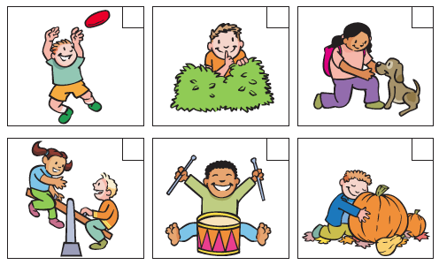
 | 2.0

K.G.01 / 2.0
Use a small object such as a bean bag.
Teacher says, “Put the bean bag _______you.”
Student should know 3 of 5.

Term | ✓ | Term | ✓
next to |  | below
behind |  | in front of
above

K.G.01 / 3.0

Use a small object such as a bean bag.
Teacher says, “Put the bean bag _______you.

Term | ✓ | Term | ✓
next to |  | below
behind |  | in front of
above

Show students pictures and models of the following 2D and 3D shapes.

Term | ✓ | Term | ✓
square |  | cylinder
circle |  | cone
triangle |  | cube
rectangle |  | sphere
hexagon

